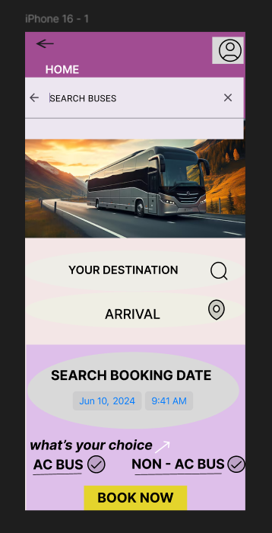

\* GOOD DESIGN:

* EASY TO SEARCH THE DESTINATION STOP AND ARRIVAL STOP OF THE BUS WITH LOCATION
* ALL OPTIONS ARE EASY TO ACCESS
* WE CAN ALSO SEARCH FOR BUSES FOR FUTURE BOOKING WITH BOOKING DATE CAN BE CHOSEN
* WE CAN SELECT THE TYPE OF BUS, BY CLICKING THE TYPE OF BUS(AC/NON-AC) AND SIMULTANEOUSLY WE CAN SELECT OUR SEAT NUMBER AND ALSO SLEEPER/NORMAL SEATER,WHERE THE AVAILABILITY CAN BE CONFIRMED.
* THEN DATE CAN BE PUT
* AFTER CLICKING “BOOK NOW”, THE BOOKING WILL BE CONFIRMED.

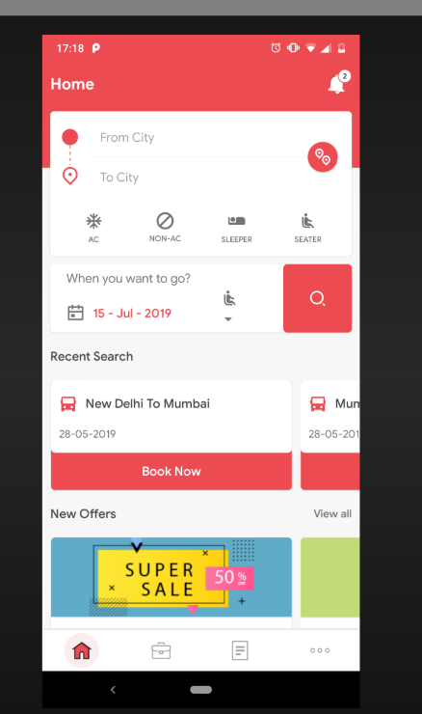

\* BAD DESIGN:

>IT IS NOT EASY TO HANDLE

> THERE ARE TOO MANY PROMOTIONS IN THE NAME OF OFFERS.

>TOO MUCH THERE FOR HANDLING THIS APP

> BOOKING IS LITTLE BIT DIFFICULT AS WE CANNOT DIRECTLY BOOK AS PER OUR COMFORT

> RECENT SEARCH IS ALSO NOT NEEDED FOR THE USER WHICH IS LOOKING BAD FOR THE APP.

> FINALLY DUE TO THE ABOVE REASONS, THIS APP FEELS LIKE A BAD DESIGN